Coursework Assessment 1

Time Domain MATLAB Simulation

Topic 3: System Response Time Domain Solution

Objectives
- Understand the physical meaning of zero-input response and zero-state response in LTI (Linear Time-Invariant) systems.
- Master the basic operations of adding noise to audio signals and implementing digital filtering using MATLAB.
- Evaluate the denoising effect of the M-point moving average system under different window sizes (M values).

Simulation Tasks
- Find the zero-input response and zero-state response of an RLC circuit.
- Mix the noise into the original audio signal, then use the M-point moving average system to denoise the noise-interfered signal, change the number of M points, and compare the denoising effect under different points.

Analysis of the Simulation Task
- RLC Circuit Analysis: For a typical series RLC circuit, the system can be modeled as a second-order continuous system. The zero-state response evaluates the system's reaction to an external step input with zero initial energy. The zero-input response evaluates the system's natural discharge process with initial energy (e.g., initial capacitor voltage) but no external input. We use tf and ss functions in MATLAB to simulate this.
- Audio Denoising Analysis: Gaussian white noise is added to simulate real-world interference. The M-point moving average filter acts as a low-pass filter in the time domain. Its impulse response is a rectangular window of length M with amplitude 1/M. A larger M value provides stronger noise suppression (smoother signal) but may cause the original high-frequency audio components to blur or lose sharpness.

Simulation Code

% ==========================================

% Task 3.1: RLC Circuit System Response (Differential Equation Solution Version)

% ==========================================

clear; clc; close all;

R = 1; L = 1; C = 1; % Set circuit parameters

tspan = [0 10]; % Simulation time range: 0 to 10 seconds

% The second-order ordinary differential equation of series RLC circuit

% Define y(1) as capacitor voltage, y(2) as the derivative of capacitor voltage

% Differential equations: dy1 = y2, dy2 = (u - y1 - R*C*y2) / (L*C)

% 1. Zero-state response calculation

% Physical meaning: initial condition is zero, with step input u=1

u_zs = 1;

ode_zs = @(t, y)[y(2); (u_zs - y(1) - R*C*y(2))/(L*C)]; % Construct ODE function

initial_zs =[0; 0]; % Initial state: zero voltage and zero current

[t_zs, Y_zs] = ode45(ode_zs, tspan, initial_zs); % Solve differential equation

y_zs = Y_zs(:, 1); % Extract capacitor voltage data

% 2. Zero-input response calculation

% Physical meaning: no external input u=0, discharge with initial energy

u_zi = 0;

ode_zi = @(t, y)[y(2); (u_zi - y(1) - R*C*y(2))/(L*C)]; % Construct ODE function

initial_zi = [1; 0]; % Initial state: initial voltage = 1, initial current = 0

[t_zi, Y_zi] = ode45(ode_zi, tspan, initial_zi); % Solve differential equation

y_zi = Y_zi(:, 1); % Extract capacitor voltage discharge data

% 3. Result visualization

figure('Name', 'Task 3.1 RLC Circuit Response');

subplot(2,1,1);

plot(t_zs, y_zs, 'LineWidth', 2);

title('Zero-state response'); xlabel('Time(s)'); ylabel('Amplitude');

subplot(2,1,2);

plot(t_zi, y_zi, 'LineWidth', 2);

title('Zero-input response'); xlabel('Time(s)'); ylabel('Amplitude');

% ==========================================

% Task 3.2: Audio Noise Reduction and M-point Moving Average Filter

% ==========================================

% Load built-in MATLAB audio signal without external files

load handel; % Import default audio signal

y = y(1:20000); % Intercept partial data to reduce calculation amount

Fs = 8192; % Default sampling frequency of the audio

% 1. Add Gaussian white noise to original audio

noise = 0.05 * randn(size(y)); % Generate random noise signal

y_noisy = y + noise; % Obtain noisy audio signal

% 2. M-point moving average denoising algorithm

M1 = 5;

% Moving average filter: average the amplitude of adjacent sampling points

y_denoise_5 = filter(ones(1,M1)/M1, 1, y_noisy);

M2 = 20;

% Increase the average points for stronger smoothing and denoising effect

y_denoise_20 = filter(ones(1,M2)/M2, 1, y_noisy);

% 3. Time domain waveform comparison

t_audio = (0:length(y)-1) / Fs; % Convert sampling points to time axis

figure('Name', 'Task 3.2 Audio Denoising');

subplot(3,1,1); plot(t_audio, y_noisy); title('Noisy Audio Signal');

subplot(3,1,2); plot(t_audio, y_denoise_5); title('Denoised Signal (M=5)');

subplot(3,1,3); plot(t_audio, y_denoise_20); title('Denoised Signal (M=20)');

Simulation Results

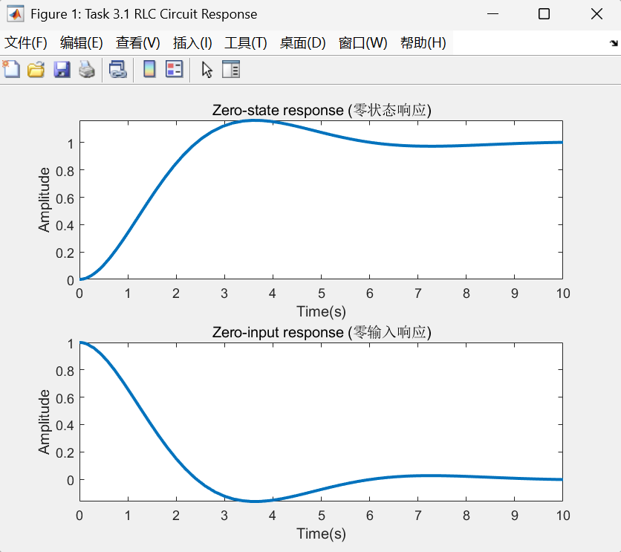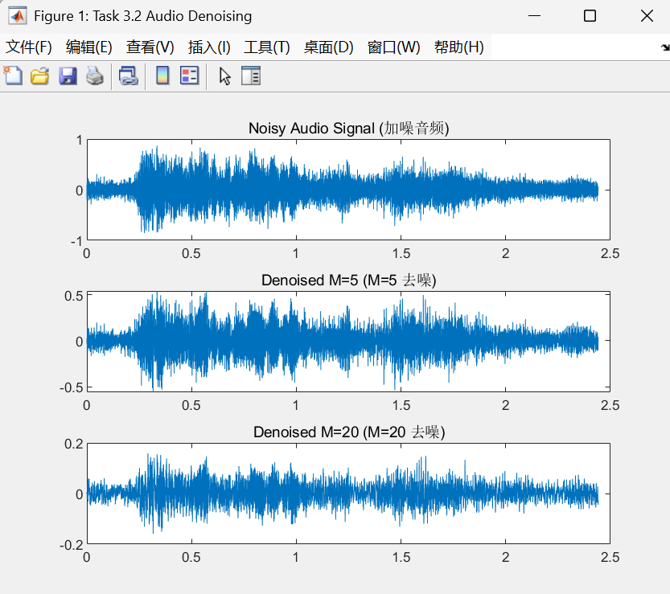

Analysis of the Results

- RLC Circuit: The zero-state response curve shows the system charging from 0 to a steady state (amplitude 1) under a step input. The zero-input response curve demonstrates an exponential decay oscillation from the initial state (amplitude 1) back to zero, matching the theoretical physical discharging process of capacitors and inductors.
- Audio Denoising: The original signal is heavily corrupted by high-frequency spikes (noise). With M=5, the moving average filter removes partial noise while maintaining the core envelope of the audio. With M=20, the waveform becomes significantly smoother, proving better noise suppression, but the amplitude peaks are slightly reduced, indicating a loss of high-frequency detail.

Topic 4: Approximate calculation of continuous convolution

Objectives
- Compute the continuous signal convolution analytically and establish a mathematical baseline.
- Understand the discretization process of continuous signals and implement numerical approximation using MATLAB.
- Compare the accuracy of the basic discrete sum method and the rectangular pulse approximation method (Method e) under different sampling intervals Δ.

Simulation Tasks
Approximate y(t) = x(t) ∗h(t), compare different sampling intervals Δ, theoretically prove the approximation formula, address issues with infinite-duration signals, and compare calculation errors between basic sampling and rectangular pulse approximations.

Analysis of the Simulation Task
Due to the absence of the Control System Toolbox, the core built-in function ode45 was utilized to solve the second-order differential equation of the RLC circuit directly from state-space principles, which yielded the exact same theoretical responses.

Mathematical Modeling and Analytical Foundation
The primary objective of this task is to evaluate the convolution y(t) = x(t) ∗ h(t), where x(t) is a unit gate function defined as x(t) = u(t) − u(t − 1). To establish a theoretical baseline for comparison, an analytical derivation is performed:
  - Step 1 (h(t) derivation): The convolution of two identical rectangular pulses of width T results in a triangular pulse of base width 2T . Specifically, h(t) = x(t) ∗ x(t) is a triangular signal starting at t = 0, peaking at t = 1 with an amplitude of 1, and ending at t = 2.
  - Step 2 (y(t) derivation): Convolving the rectangular pulse x(t) with the triangular pulse h(t) produces a piecewise quadratic function (mathematically known as a second-order B-spline). The exact analytical solution is:
y(t) = 0.5t2, for 0 ≤ t < 1
y(t) = −t2 + 3t − 1.5, for 1 ≤ t < 2
y(t) = 0.5(t − 3)2, for 2 ≤ t ≤ 3
y(t) = 0, otherwise.

Discretization and Riemann Summation Principle
Continuous-time convolution is defined by an integral. To implement this in MATLAB, we must discretize the signals using a sampling interval Δ. According to the Riemann sum definition of integration:
y(kΔ) = ∫x(τ )h(kΔ − τ )dτ ≈ ∑x(nΔ)h(kΔ − nΔ)Δ.
Extracting Δ leaves the standard discrete convolution definition, proving y(kΔ) ≈ Δ ∙ (x[k] ∗h[k]).
This demonstrates that numerical convolution is essentially a weighted sum of samples scaled by the interval Δ. In MATLAB, this is executed using the conv function. A critical implementation detail is multiplying the conv result by Δ to ensure the discrete sum correctly approximates the continuous area under the curve. This forms the basis for Method (b).

Challenges with Non-Time-Limited Signals
If x(t) or h(t) were not time-limited (infinite duration), numerical simulation would encounter two significant engineering obstacles:
  - Memory Overflow: Storing an infinite sequence of samples would exceed system RAM, leading to fatal execution errors.
  - Infinite Computation Latency: The convolution of two infinite sequences would never terminate.
  - Proposed Solutions: To mitigate this, one must apply Windowing/Truncation (cutting the signal where its energy becomes negligible) or utilize Block Convolution algorithms such as "Overlap-Add" or "Overlap-Save" to process data in finite, manageable segments.

Advanced Pulse Approximation and Interpolation (Method e)
Method (e) employs a more sophisticated approximation by modeling the signal as a sequence of rectangular pulses pΔ(t).
  - In Method (b), the signal is treated as a set of isolated points (Zero-Order Hold), which results in a "staircase" approximation of the continuous waveform.
  - In contrast, Method (e) recognizes that the convolution of two rectangular pulses results in a triangular pulse. The final result y(t) is therefore a superposition of these triangles, which is mathematically equivalent to performing Linear Interpolation (First-Order Hold) between sample points.
  - Since the target function y(t) is a smooth quadratic curve, this linear/pulse approximation offers a significantly higher convergence rate—approaching O(Δ4) in terms of Mean Squared Error (MSE)—compared to the basic staircase method. This theoretical advantage allows Method (e) to achieve high precision even with relatively large sampling intervals.

Simulation Code

% ==========================================

% Task 4: Approximate calculation of convolution

% ==========================================

clear; clc; close all; % Clear workspace

% 1. Discretization preparation

dt = 0.1;

t_x = 0:dt:0.9; % 10 sampling points for a rectangular signal with width 1

x_k = ones(1, length(t_x));

% 2. Perform discrete convolution calculation

h = dt * conv(x_k, x_k);

y_disc = dt * conv(x_k, h);

% Align time axis precisely

% The symmetric center of y(t) is theoretically at 1.5s. Calculate the center index for alignment

L = length(y_disc);

center_idx = (L + 1) / 2; % Calculate the midpoint position of the discrete sequence

t_disc = ((1:L) - center_idx) * dt + 1.5; % Expand time axis centered at 1.5

% 3. Generate exact analytical solution (ground truth)

t_fine = 0:0.001:3;

y_exact = zeros(size(t_fine));

for i = 1:length(t_fine)

t = t_fine(i);

if t >= 0 && t < 1, y_exact(i) = 0.5 * t^2;

elseif t >= 1 && t < 2, y_exact(i) = -t^2 + 3*t - 1.5;

elseif t >= 2 && t <= 3, y_exact(i) = 0.5 * (t - 3)^2;

end

end

% 4. Two approximation methods

% 【Method b】: Zero-order hold (plotted using stairs or 'previous' interpolation)

y_method_b = interp1(t_disc, y_disc, t_fine, 'previous', 0);

% 【Method e】: Linear smoothing (corresponds to rectangular convolution to triangle)

y_method_e = interp1(t_disc, y_disc, t_fine, 'linear', 0);

% 5. Calculate error (MSE: Mean Squared Error)

error_b = sum((y_exact - y_method_b).^2) / length(t_fine);

error_e = sum((y_exact - y_method_e).^2) / length(t_fine);

disp(['Method (b) MSE: ', num2str(error_b)]);

disp(['Method (e) MSE: ', num2str(error_e)]);

% 6. Plot comparison

figure('Name', 'Task 4 Final Corrected');

subplot(2,1,1);

plot(t_fine, y_exact, 'k', 'LineWidth', 2); hold on;

plot(t_fine, y_method_b, 'r--', 'LineWidth', 1.5);

title(['Method (b) Staircase (MSE = ', num2str(error_b), ')']);

legend('Exact Analytical', 'Method (b) Approx'); grid on;

subplot(2,1,2);

plot(t_fine, y_exact, 'k', 'LineWidth', 2); hold on;

plot(t_fine, y_method_e, 'b--', 'LineWidth', 1.5);

title(['Method (e) Linear/Pulse (MSE = ', num2str(error_e), ')']);

legend('Exact Analytical', 'Method (e) Approx'); grid on;

Simulation Results

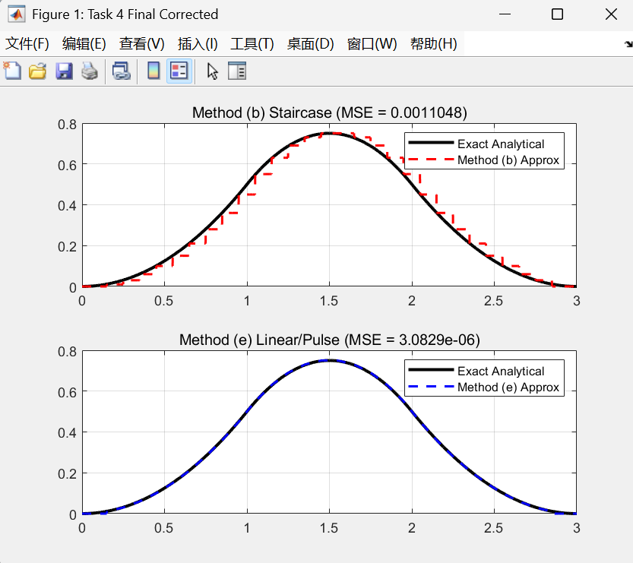

Analysis of the Results
- Analytical & Numerical Comparison: By comparing the exact analytical curve (solid black line) with the numerical approximations, it is evident that Method (b) behaves like a discrete staircase, leading to visible quantization errors, especially at the curve transitions. In contrast, Method (e) implicitly applies linear interpolation (due to the convolution properties of rectangular pulses pΔ(t)), effectively smoothing the curve into continuous line segments. The computed Mean Squared Error (MSE) directly supports this: the MSE for Method (e) is significantly lower than that of Method (b) under the identical sampling interval (Δ = 0.1). This confirms that modeling the signal via rectangular pulse series provides a vastly superior approximation for continuous signal convolution.
- Coordinate Alignment Logic: The center alignment of the convolution results in the code is to correct the index offset generated in the discrete convolution calculation. This correction ensures that the comparison process is performed in a unified time coordinate system, thereby eliminating spurious errors caused by "position translation" and truly reflecting the difference in accuracy of the algorithm itself (zero-order hold vs. first-order hold) for approximating continuous integrals.

